1. Create one VPC in N. Virginia region.

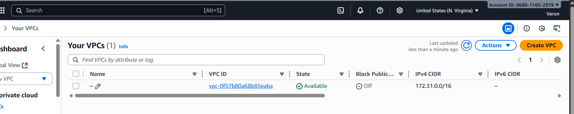

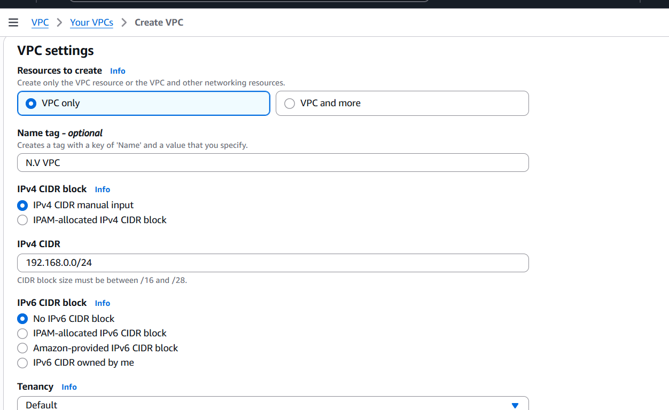

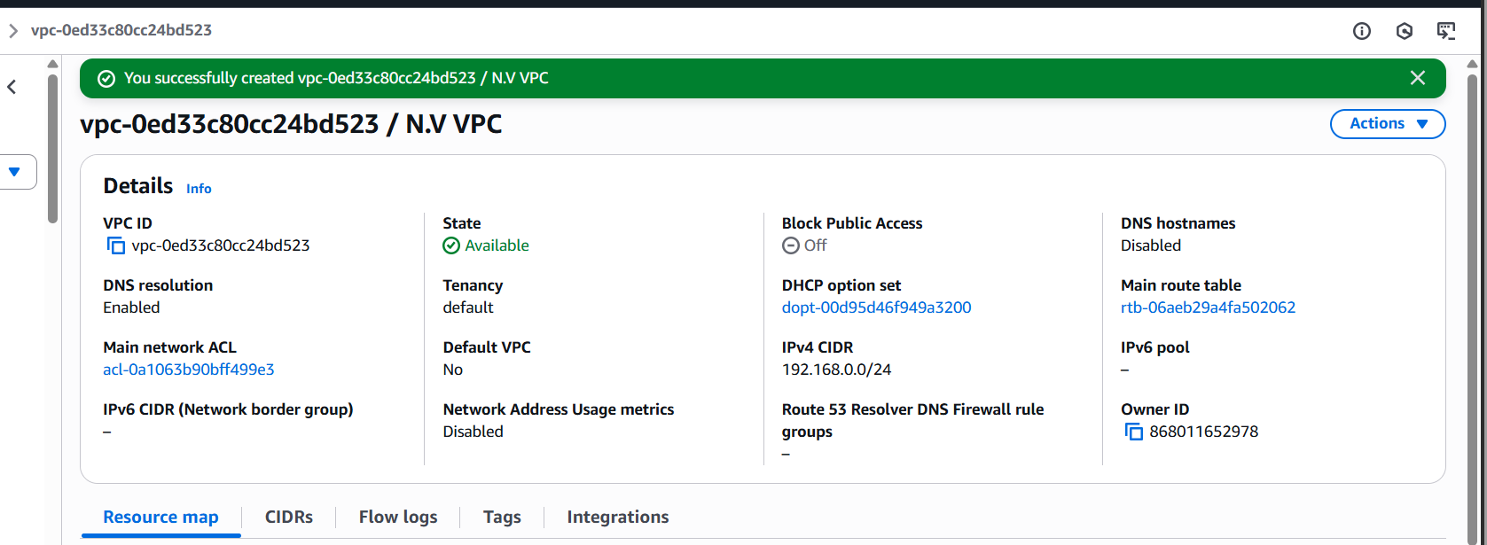

•Sign in to AWS Console  
•Switch to N. Virginia (us-east-1) region from the top-right   
dropdown.  
•Navigate to VPC Dashboard  
•Services → VPC → Your VPCs → “Create VPC”  
•Create VPC

oIPv4 CIDR block: 192.168.0.0/24 (or your preferred   
range)  
oLeave IPv6 disabled unless needed  
oTenancy: Default  
oClick Create VPC

1. Create two subnets: one public subnet and one private subnet.

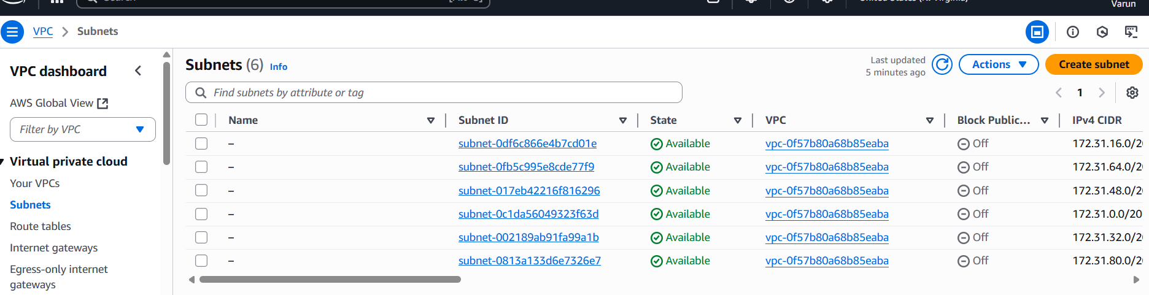

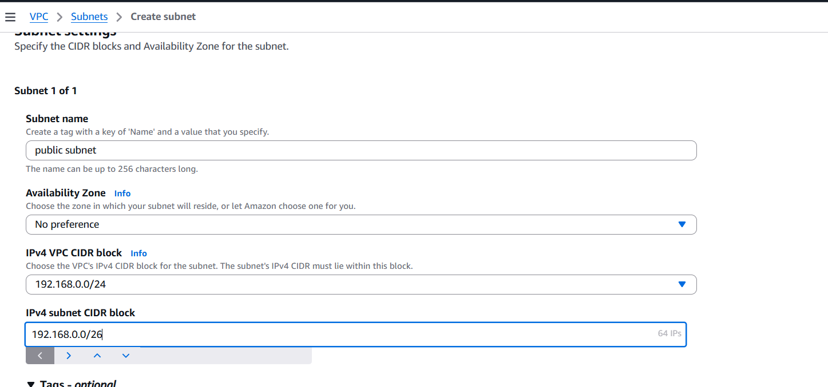

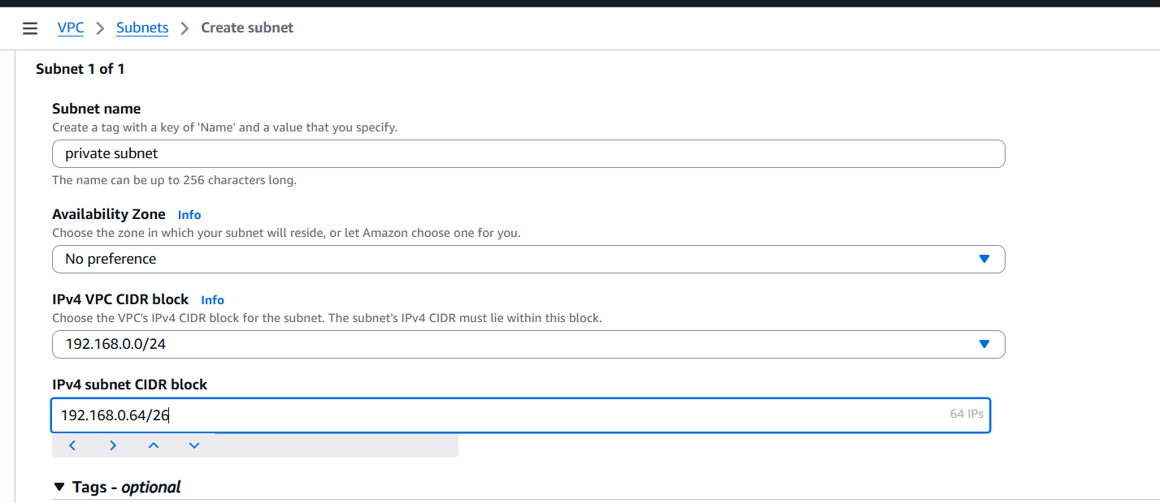

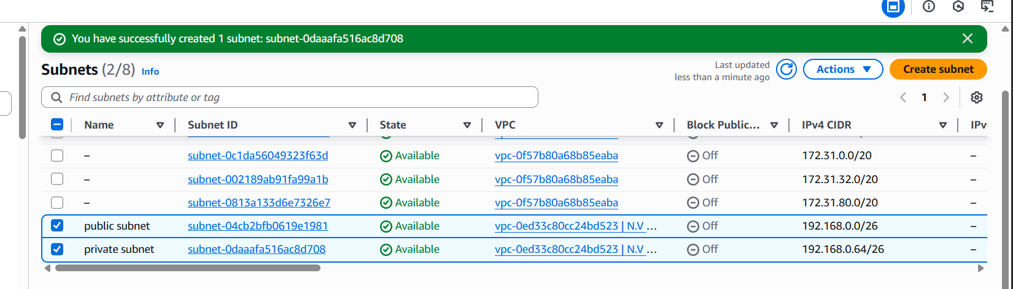

•Go to VPC Dashboard → Subnets → “Create Subnet”  
•Select your VPC  
•Name tag: PublicSubnet-01  
•Availability Zone: us-east-1a  
•IPv4 CIDR block: 192.168.0.0/26 for public , 192.168.0.64/26 for private.  
•Click Create Subnet  
•After creation, go to Subnet Actions → “Edit subnet settings”  
•Enable Auto-assign public IPv4 address

1. Attach an IGW to the VPC.

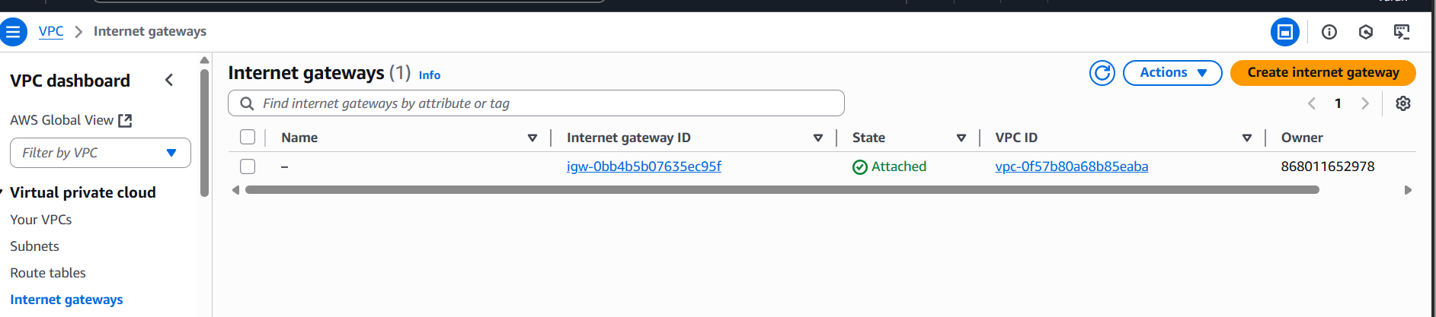

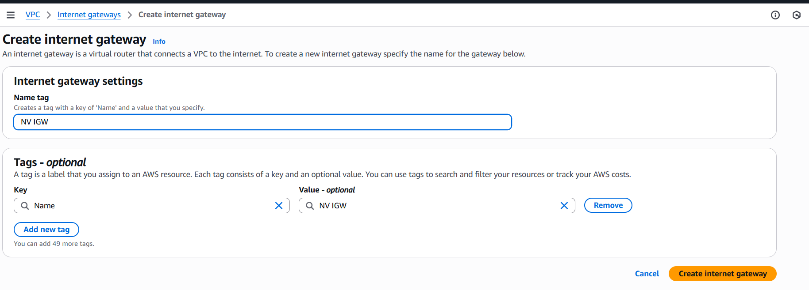

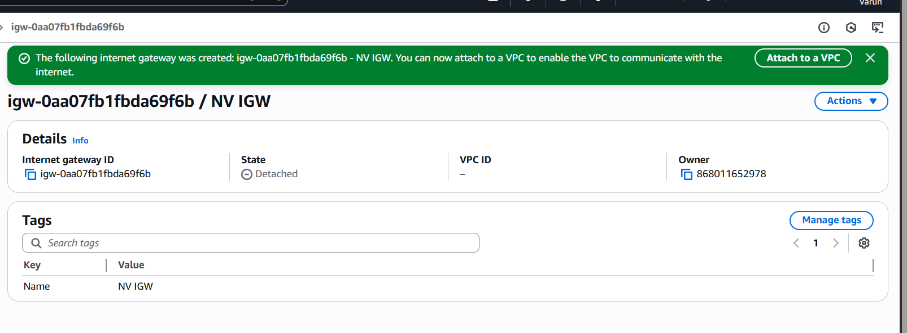

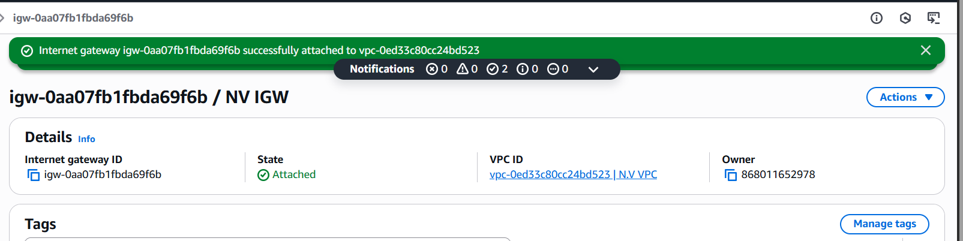

1. Go to VPC Dashboard  
oServices → VPC → Internet Gateways → “Create Internet Gateway”

2. Create IGW  
oName tag: MyIGW-NVirginia  
oClick Create Internet Gateway

3. Attach to VPC  
•Select the newly created IGW  
•Actions → “Attach to VPC”  
•Choose your VPC  
•Click Attach

1. Create one public route table (RT) and one private route table.

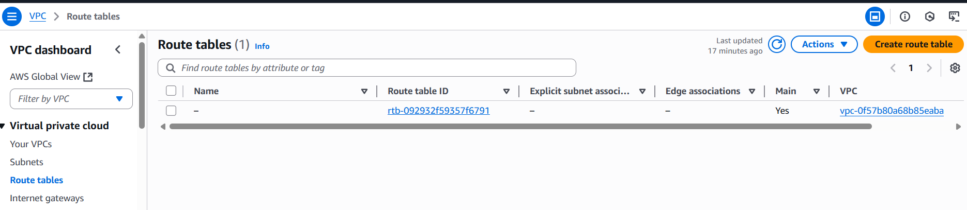

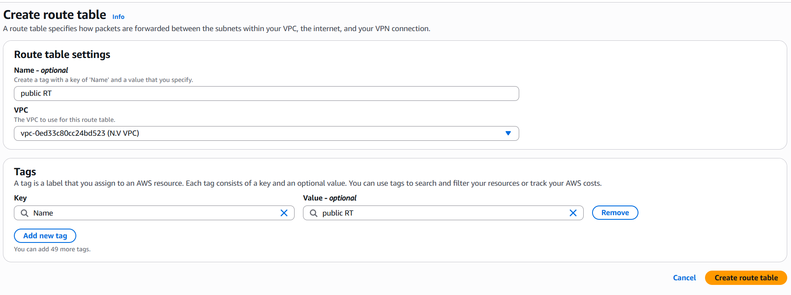

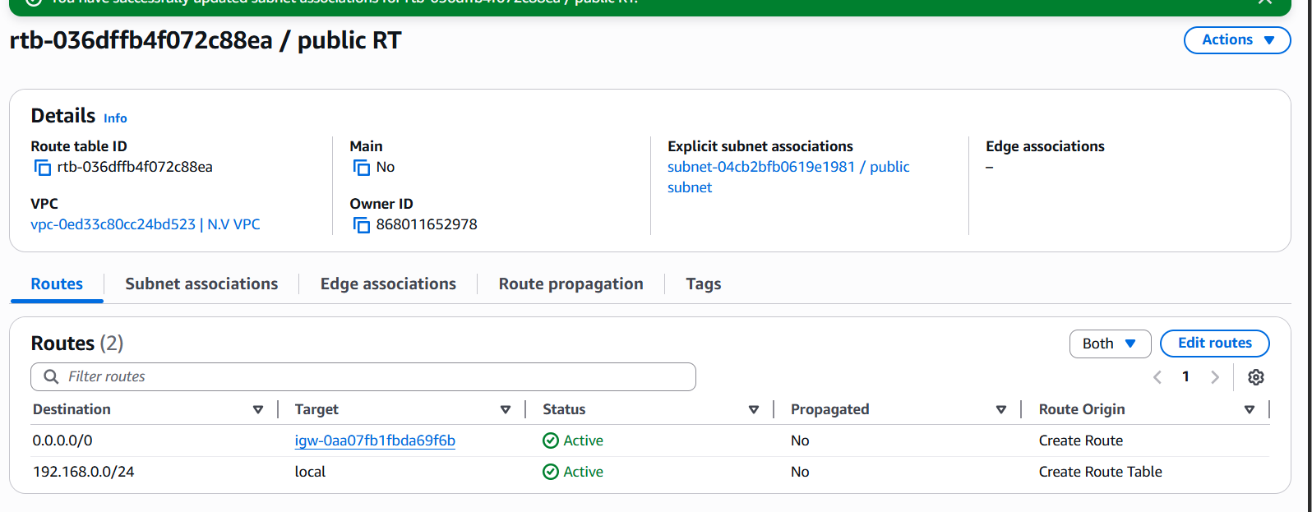

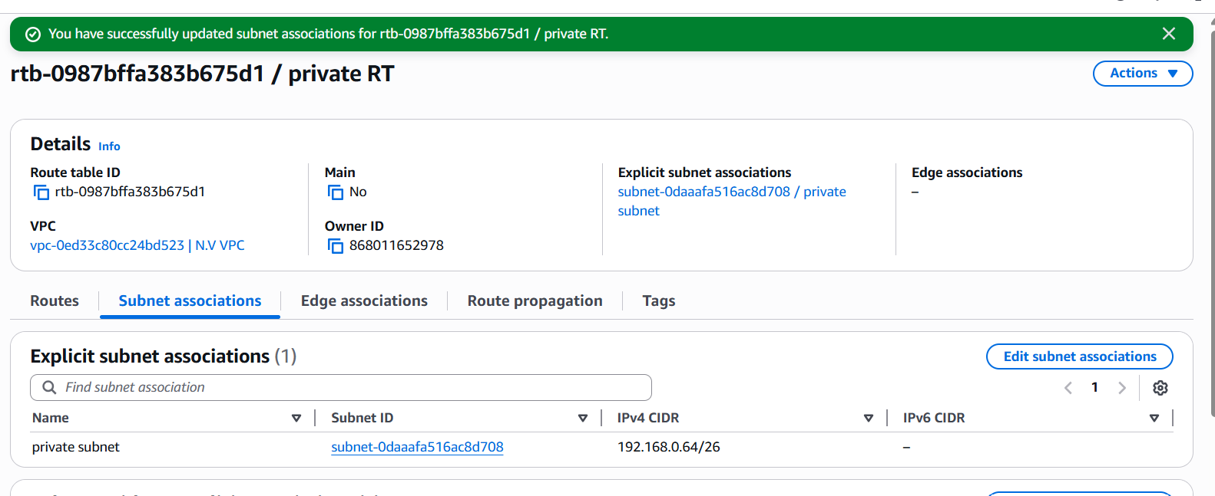

1. Go to VPC Dashboard → Route Tables → “Create route  
table”  
2. Name tag: Public RT, private RT  
3. Select your VPC  
4. Click Create

5. Select the new route table → Routes → “Edit routes”->Add route: 0.0.0.0/0 → Target: Internet Gateway (igw-xxxxxxxx)  
6. Go to Subnet Associations → “Edit subnet associations”->Select your Public Subnet

7. No need to add a 0.0.0.0/0 route unless you're using a NAT Gateway later.  
8. Associate with Private Subnet

1. Deploy a NAT gateway in the public subnet and attach the NAT gateway to the private subnet.

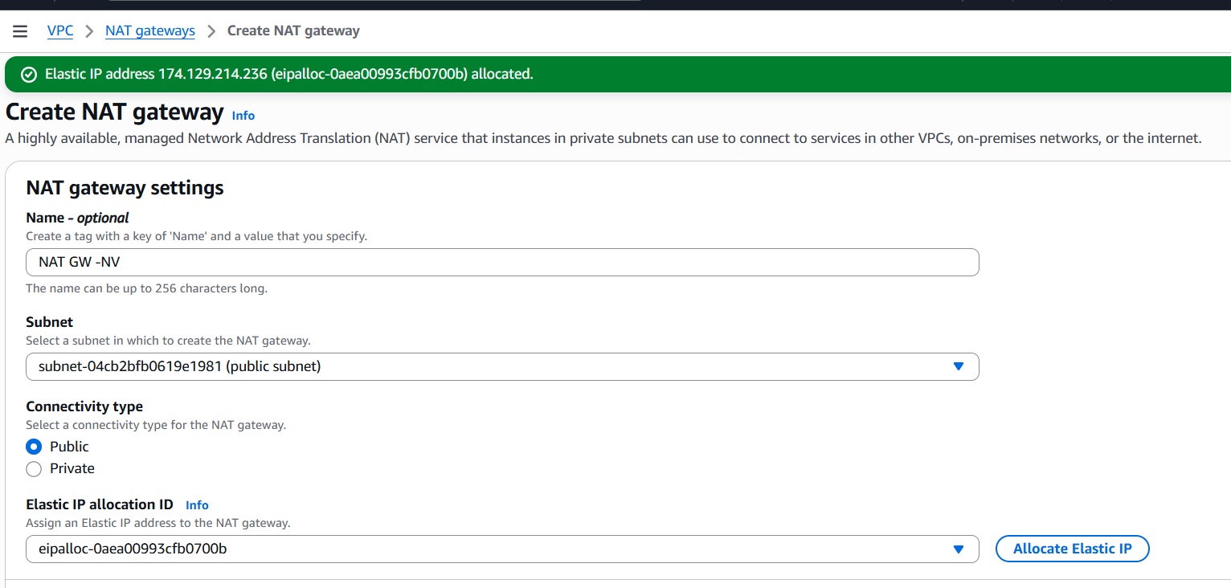

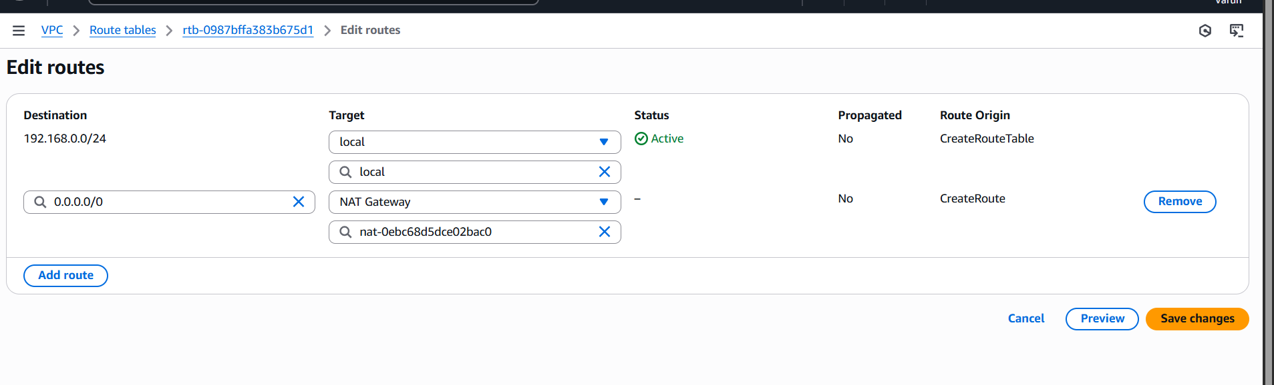

•Go to VPC Dashboard → NAT Gateways → “Create NAT Gateway”  
•Name tag: us-east-Nat  
•Subnet: Select your Public Subnet  
•Elastic IP: Select the one you just allocated  
•Click Create NAT Gateway

•Update Private Route Table  
•Go to Route Tables → Select Private RT  
•Routes → “Edit routes”  
•Add route: 0.0.0.0/0 → Target: NAT Gateway (nat - xxxxxxxx)  
•Save changes

1. Create two instances, one in the public subnet and one in the private subnet.

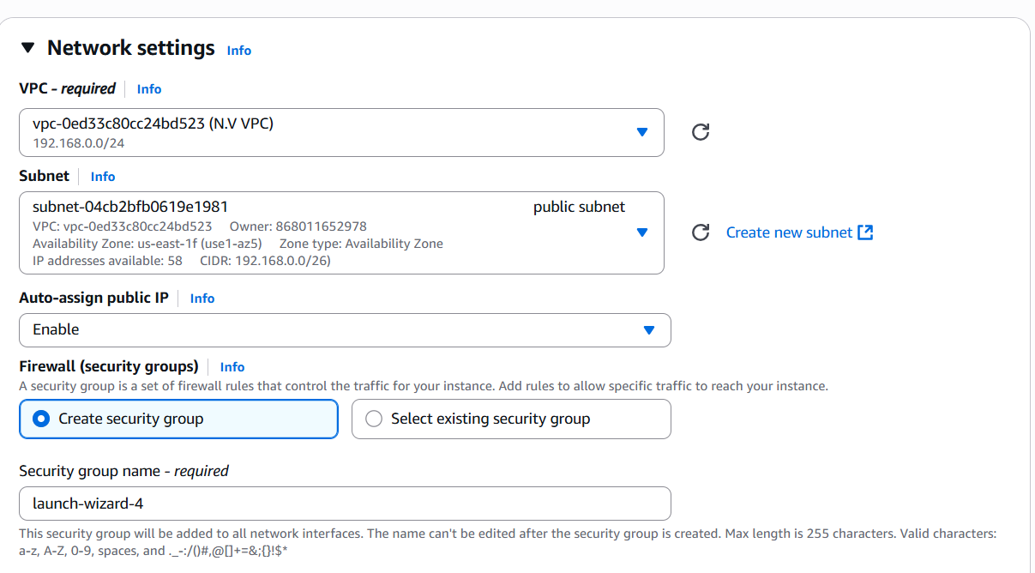

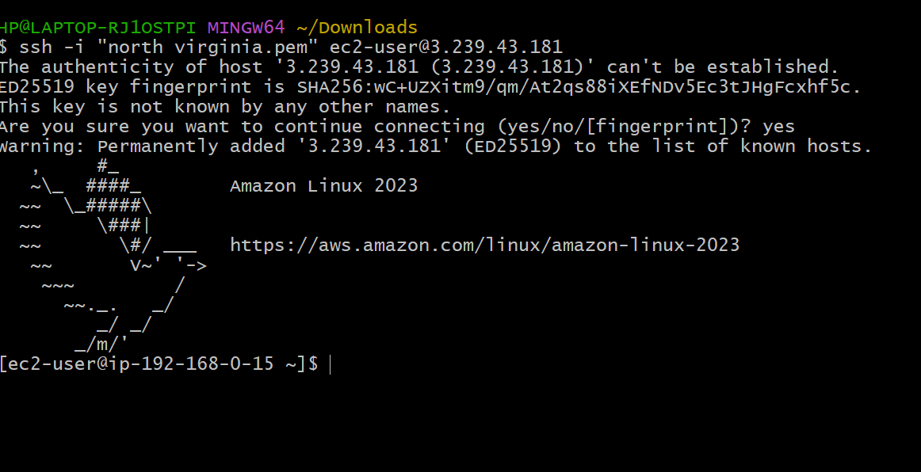

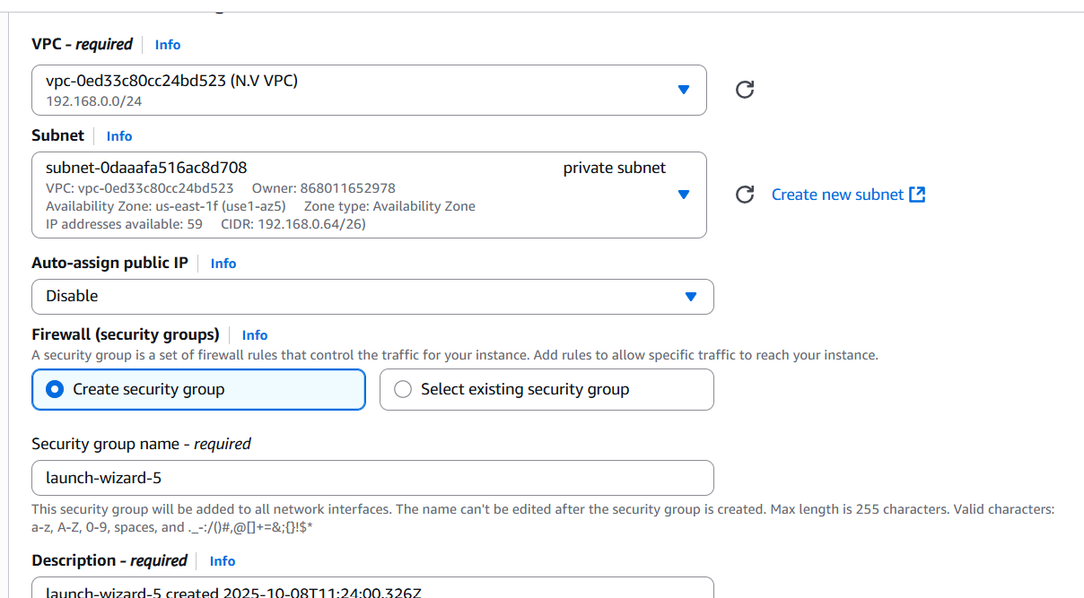

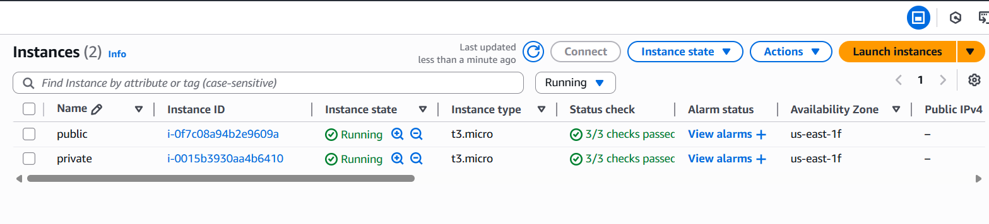

•Go to ec2 launch ec2 ->select vpc created->select public subnet->use default security group->keypair create or select->launch public instance.

•Go to ec2 launch ec2 ->select vpc created->select private subnet->use default security group->keypair create or select->launch instance.

1. Deploy Apache server on both EC2 instances with a sample index.html file.

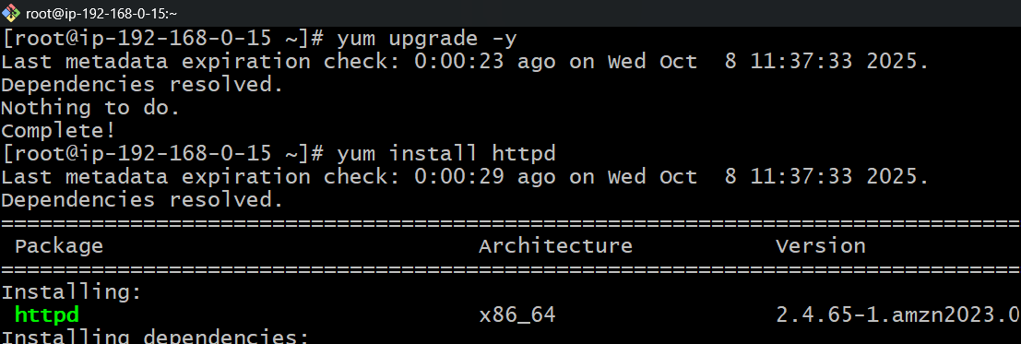

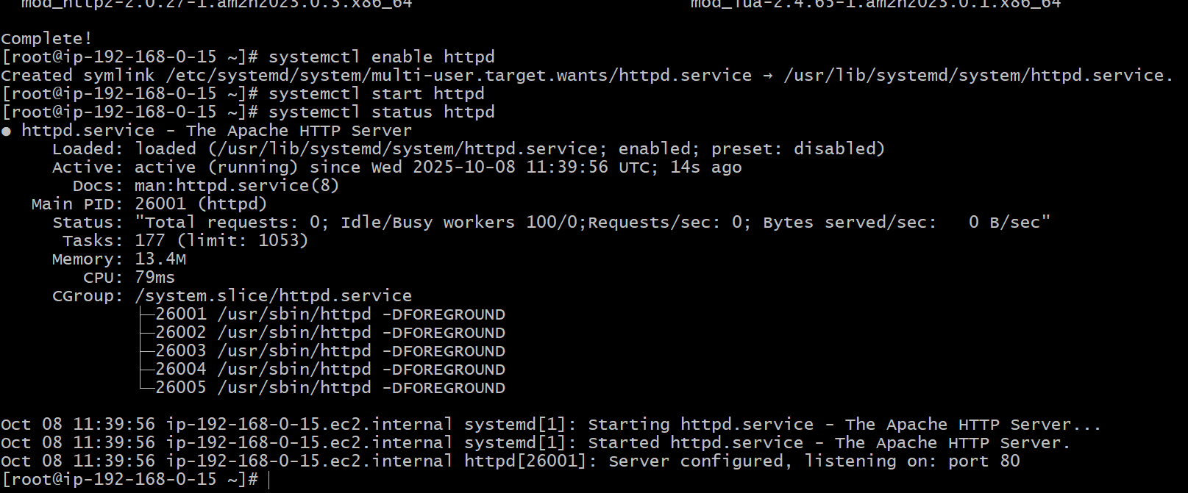

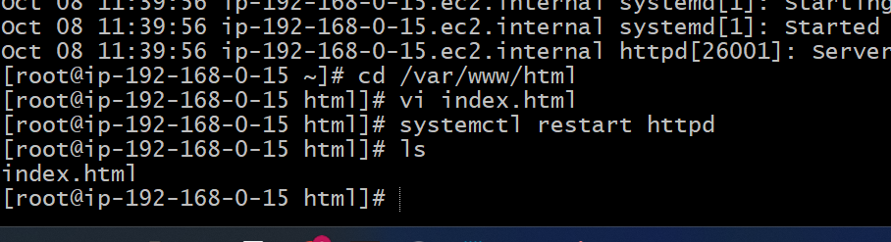

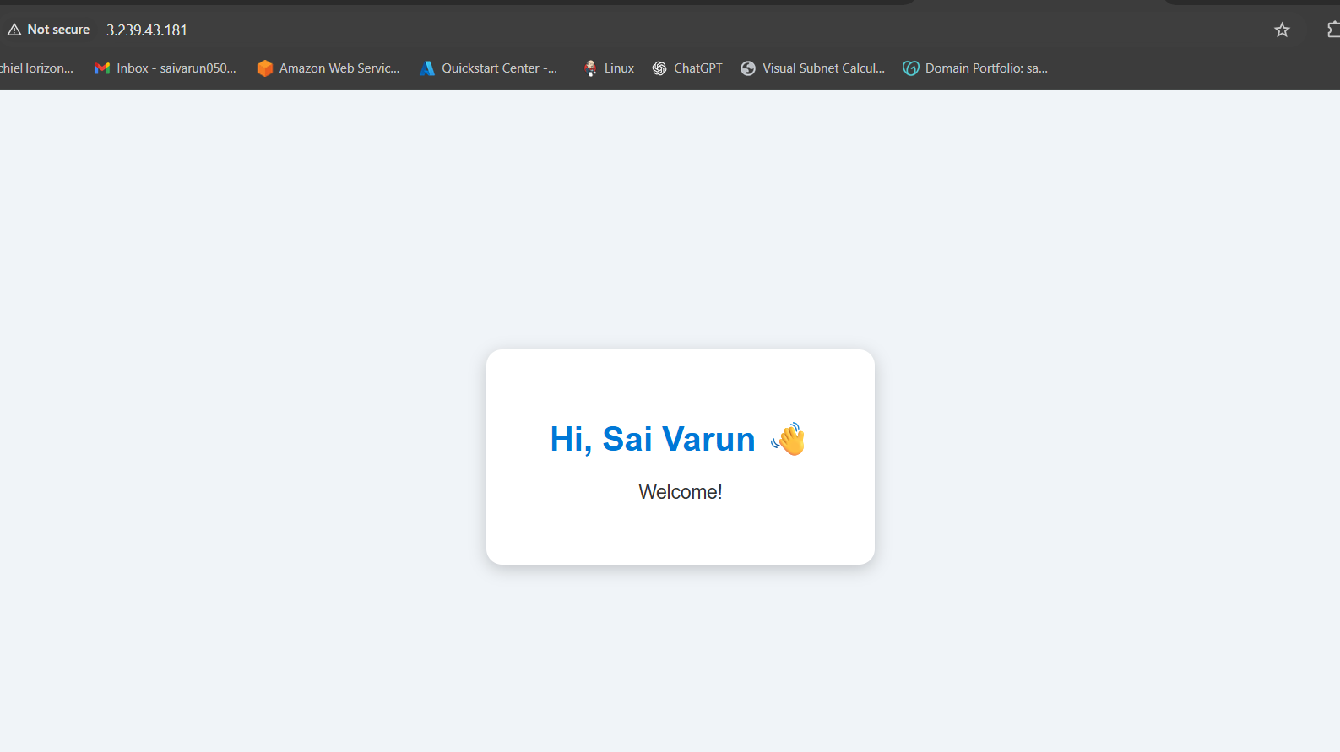

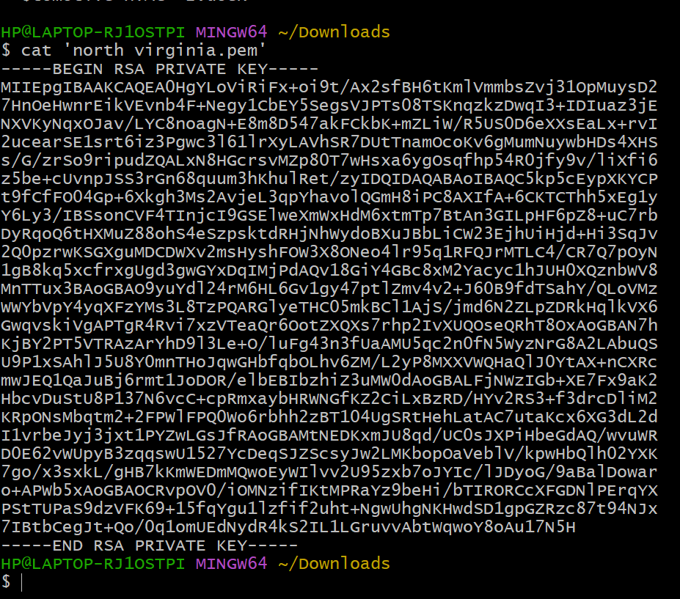

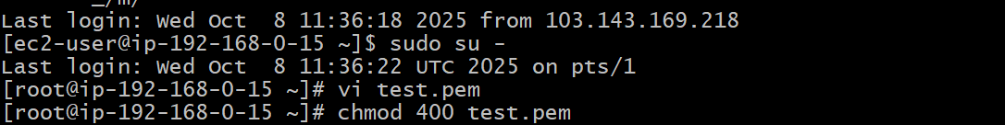

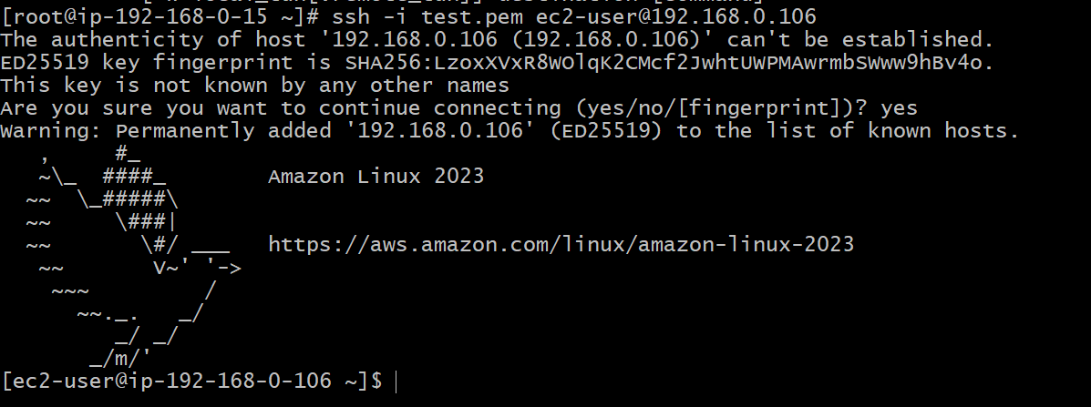

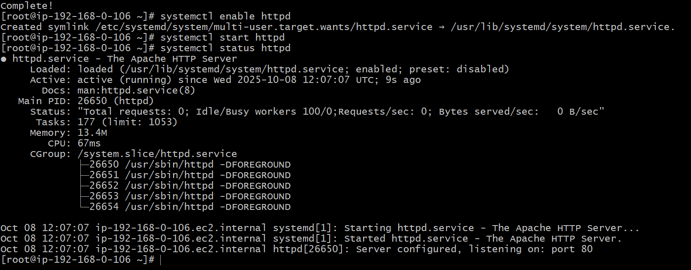

1. Create one application load balancer and attach it to both EC2 instances.

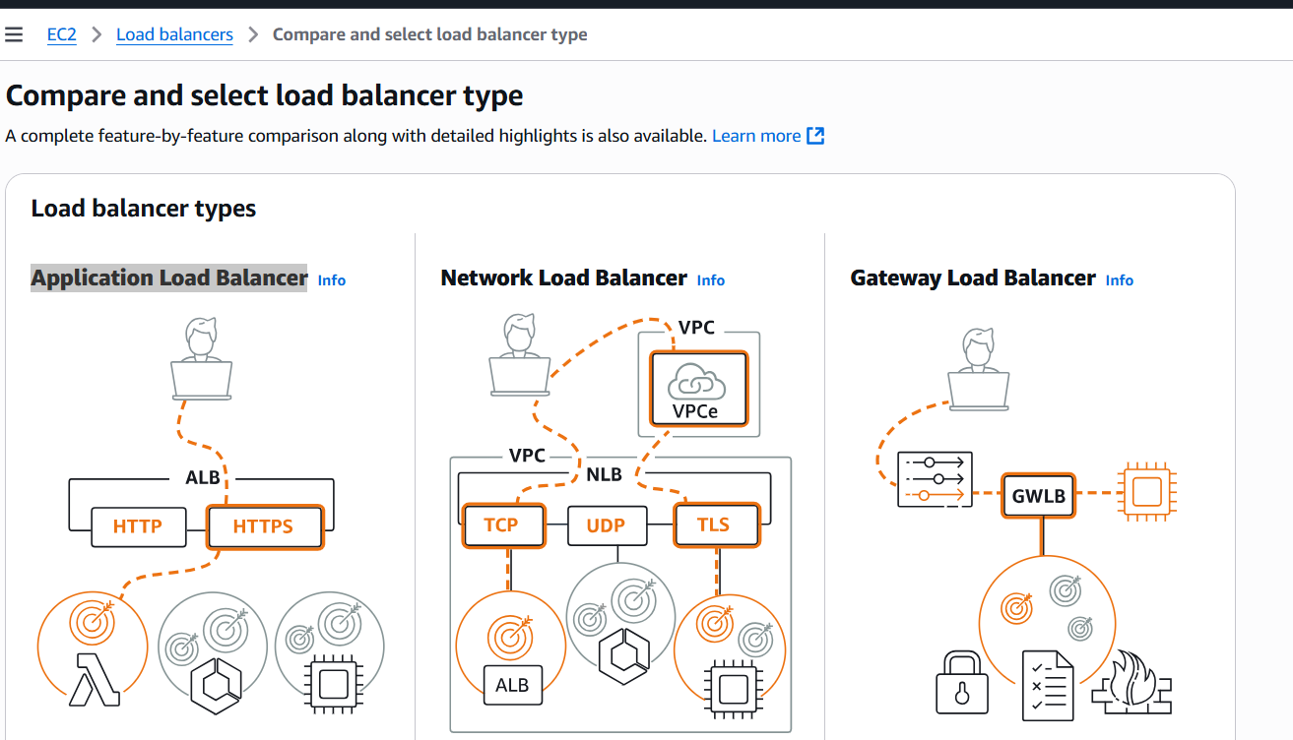

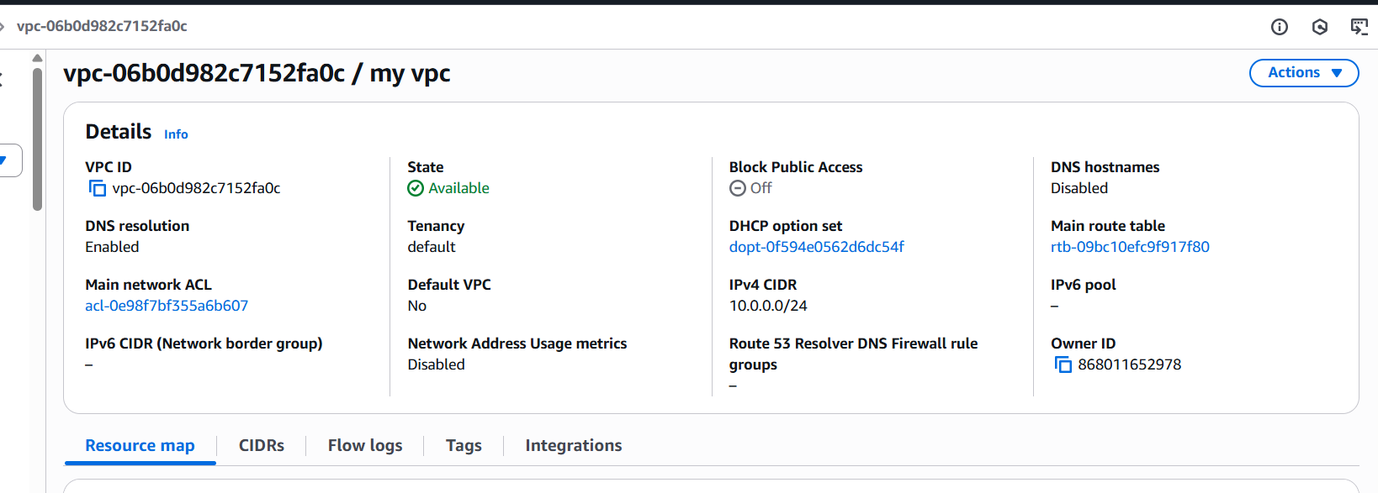

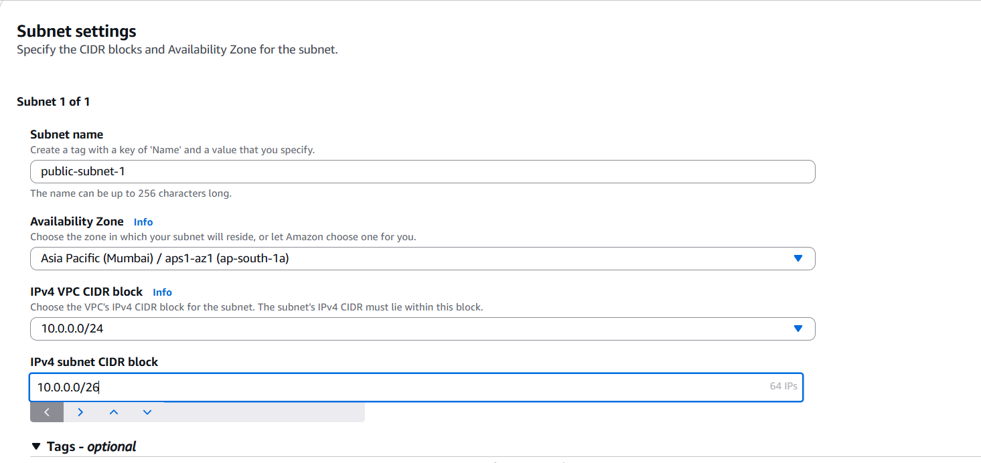

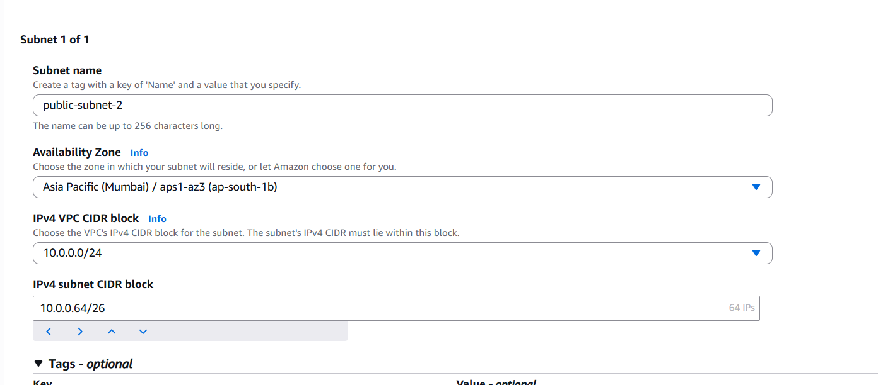

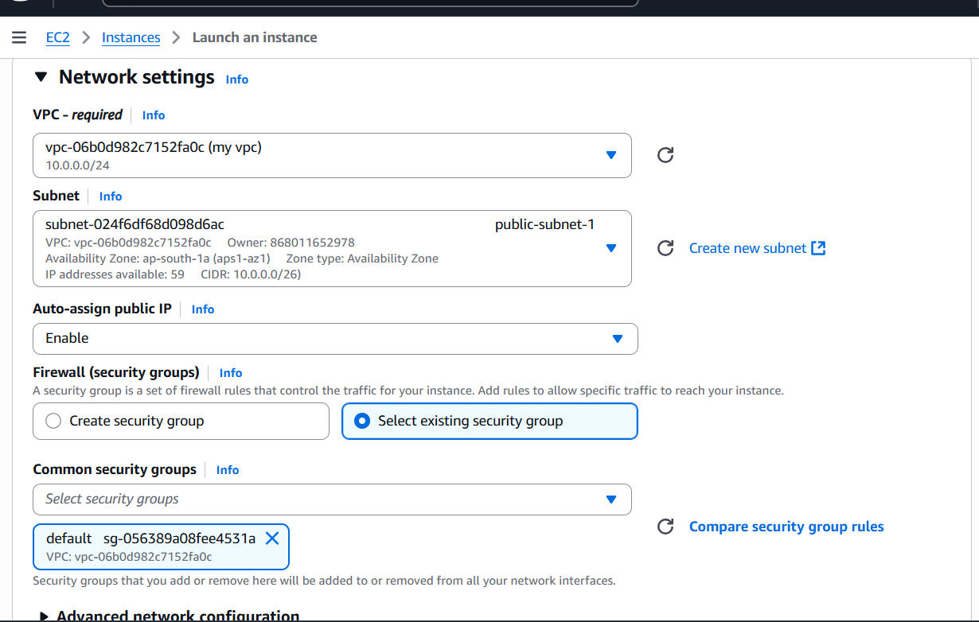

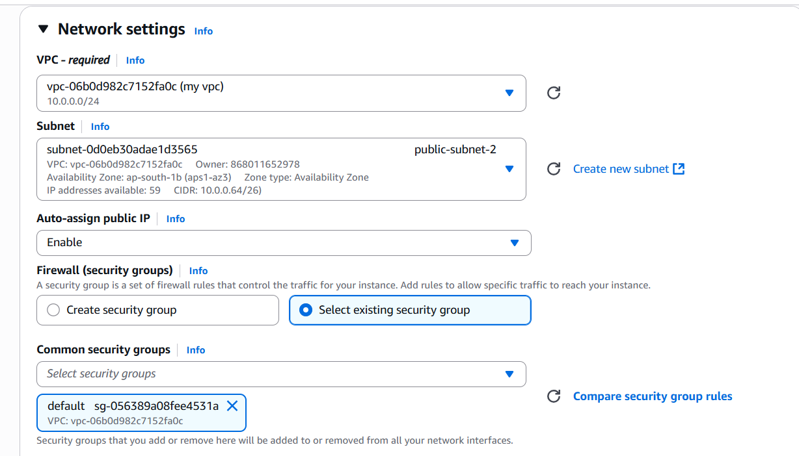

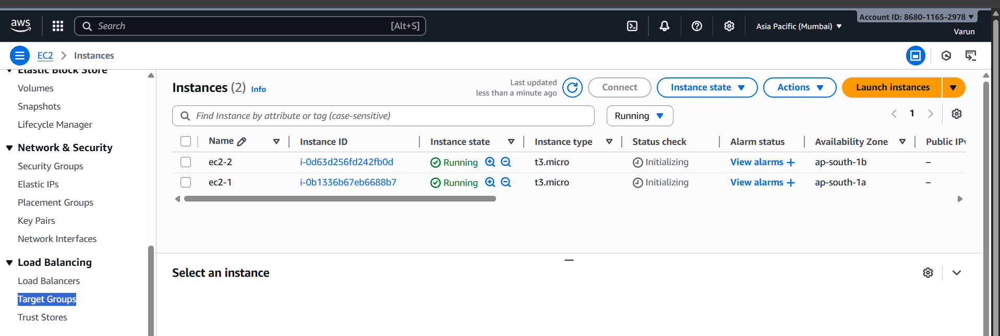

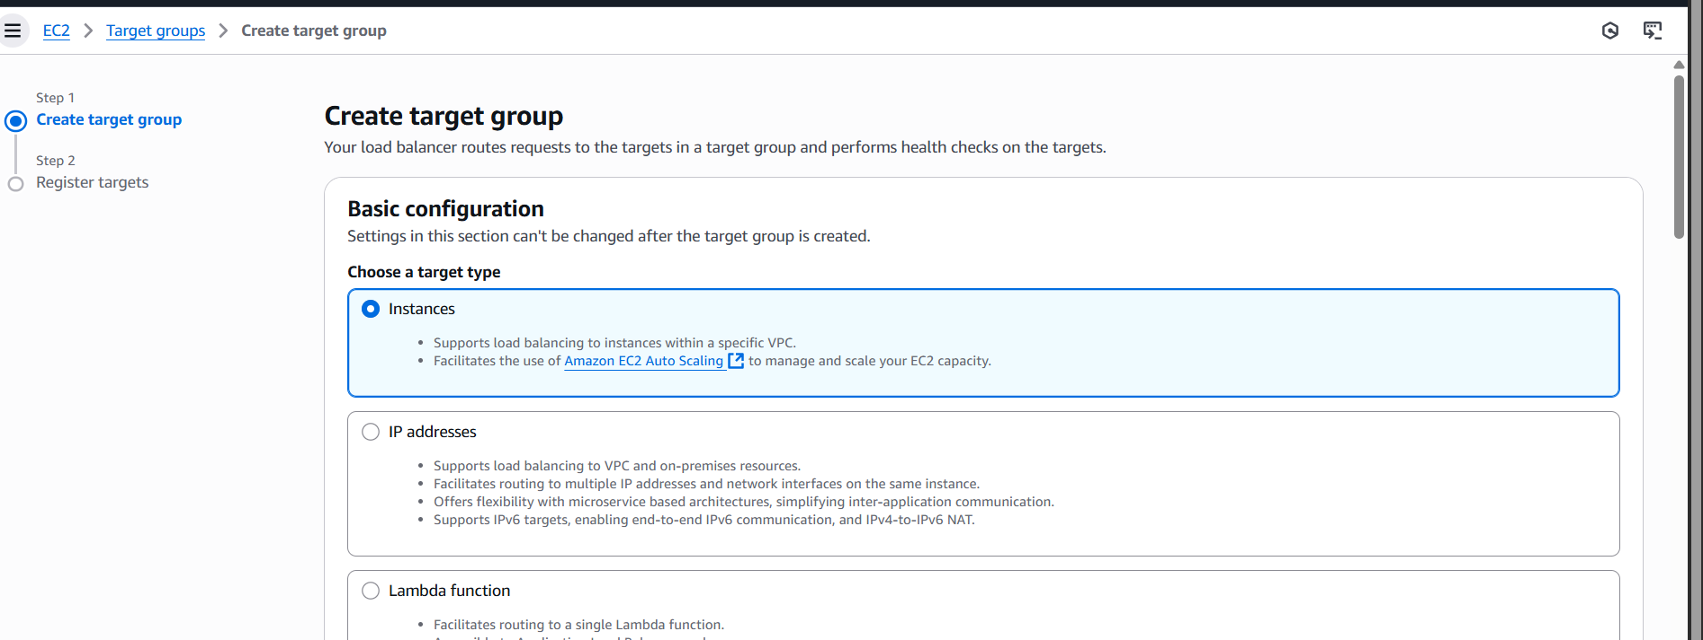

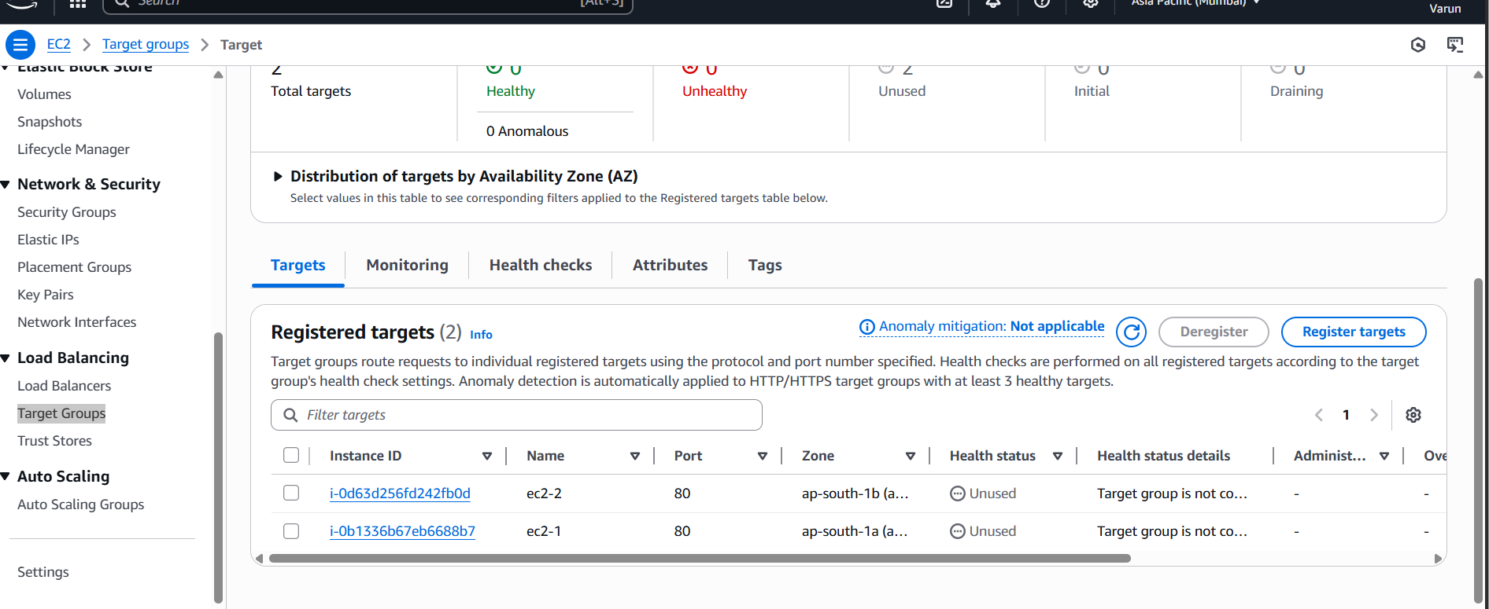

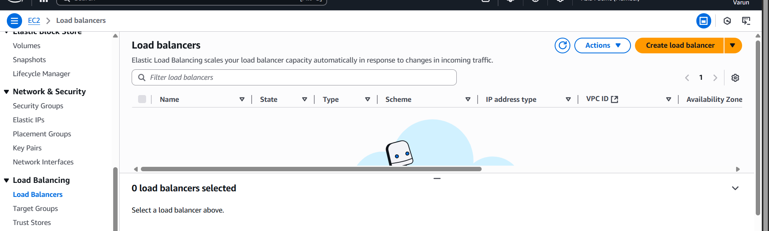

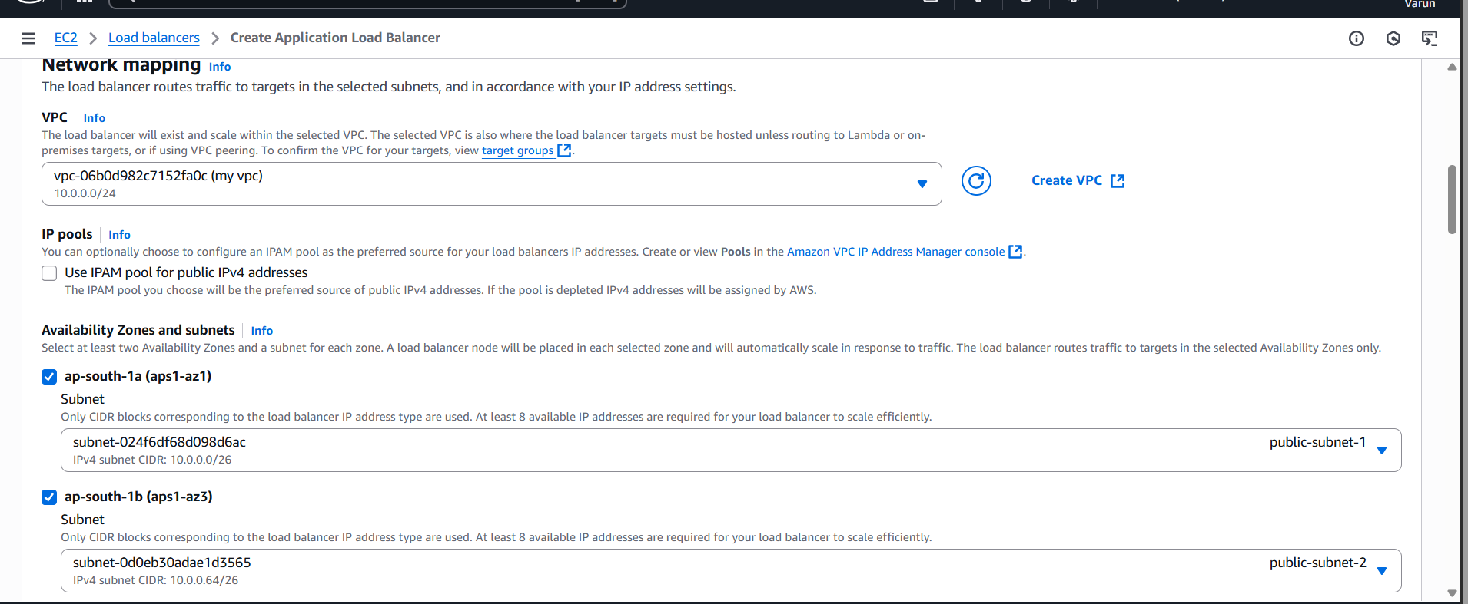

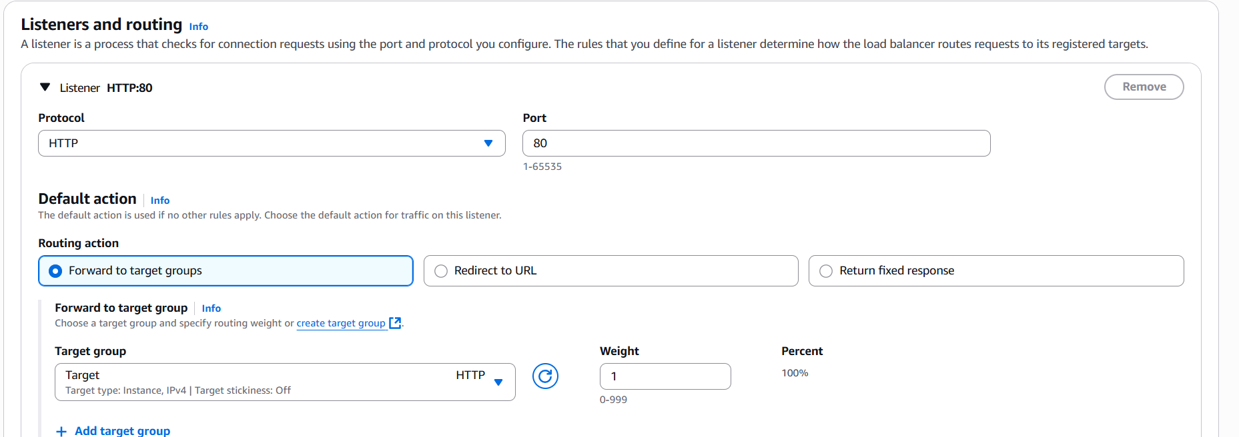

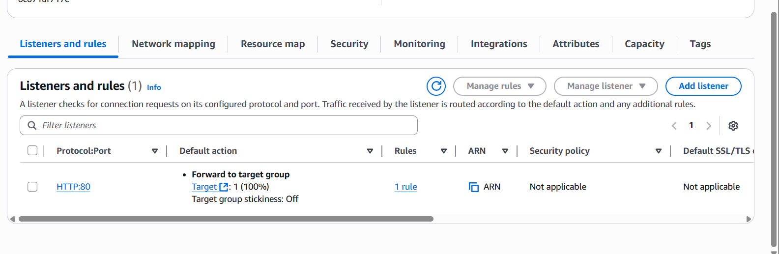

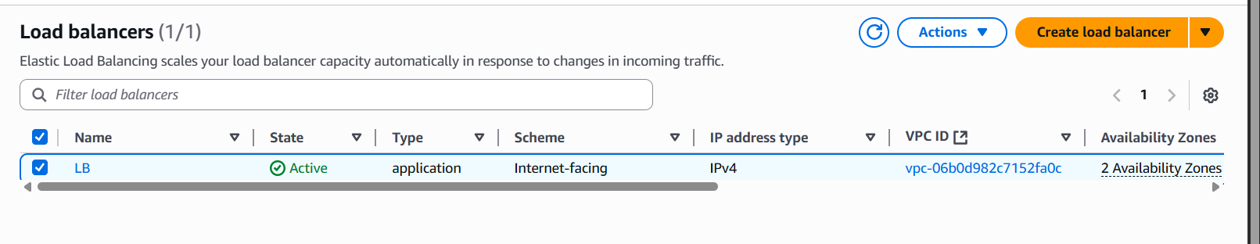

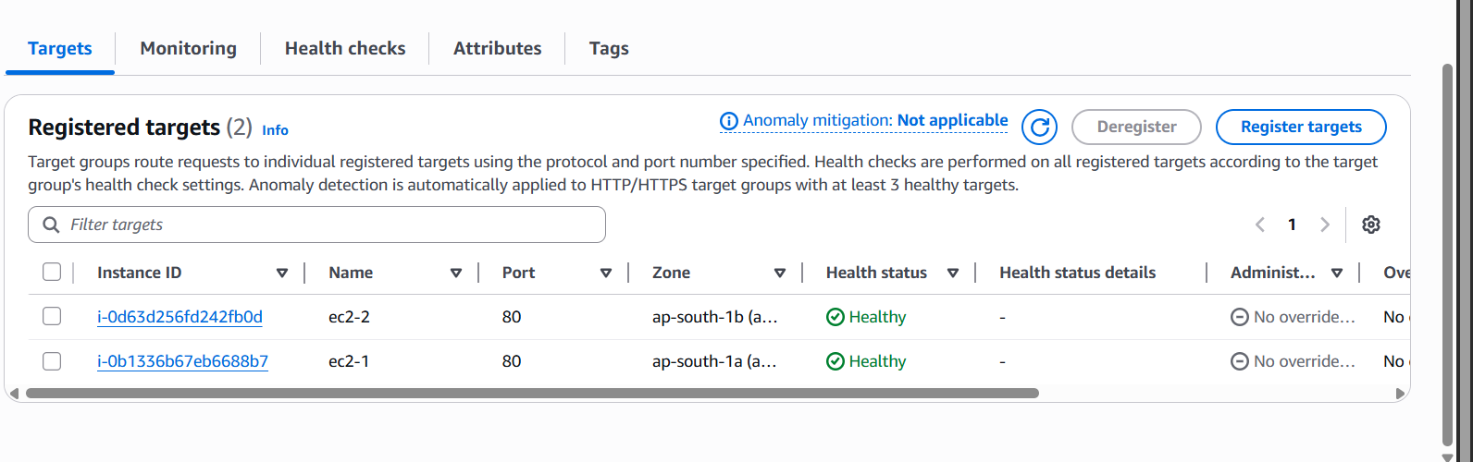

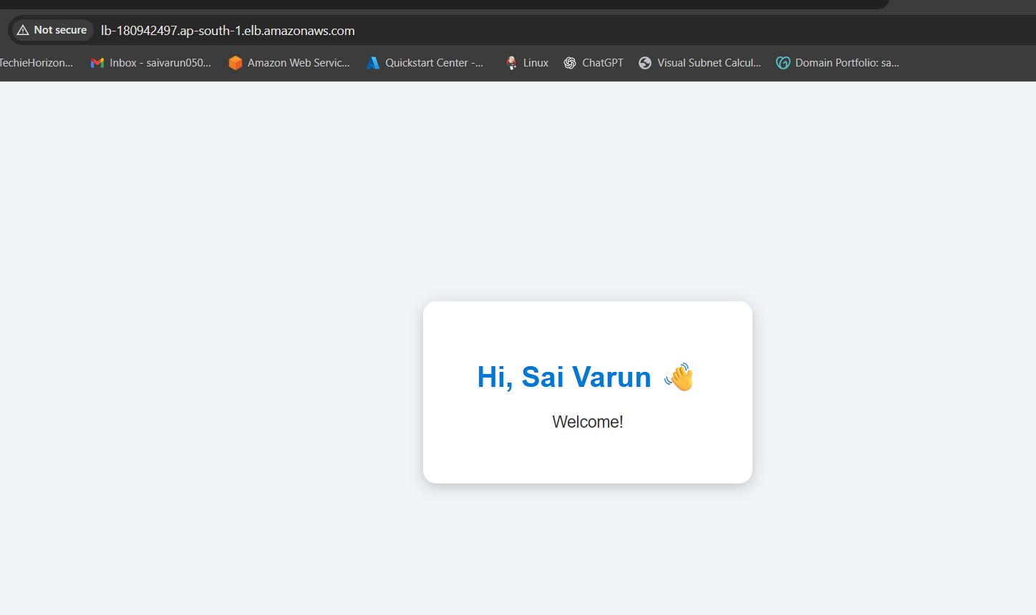

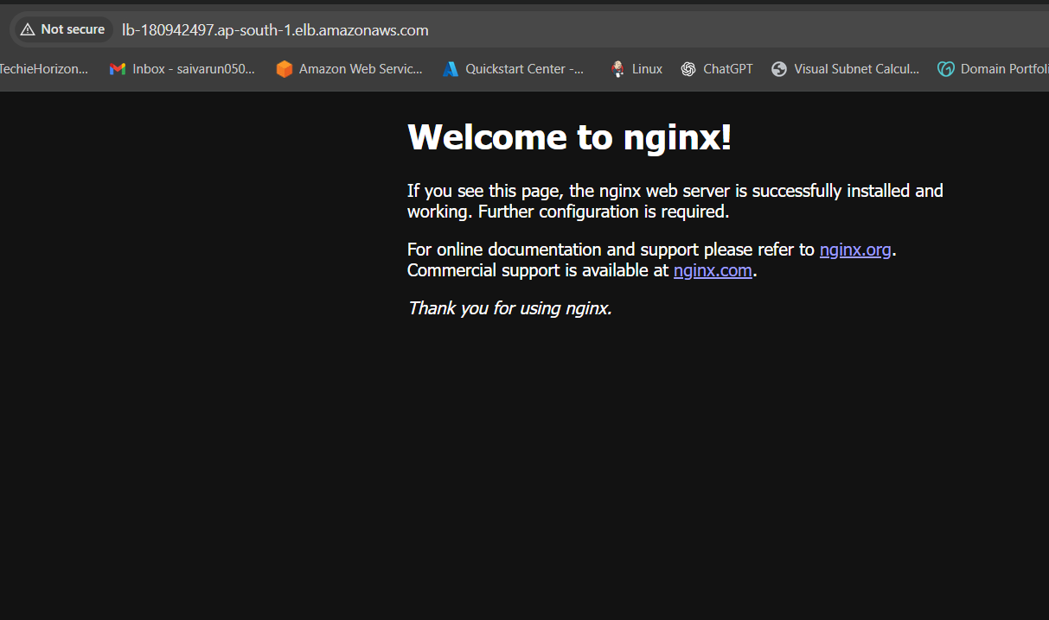

1. Store application load balancer logs in S3.

{

"Version": "2012-10-17",

"Statement": [

{

"Sid": "ALBLoggingPermissions",

"Effect": "Allow",

"Principal": {

"Service": "logdelivery.elasticloadbalancing.amazonaws.com"

},

"Action": "s3:PutObject",

**"Resource": "arn:aws:s3:::bombayy-bucket/AWSLogs/868011652978/\*"**

}

]

}

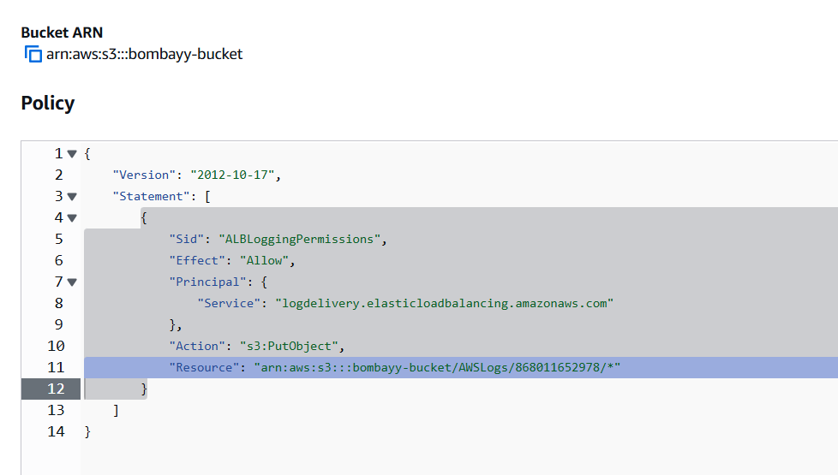

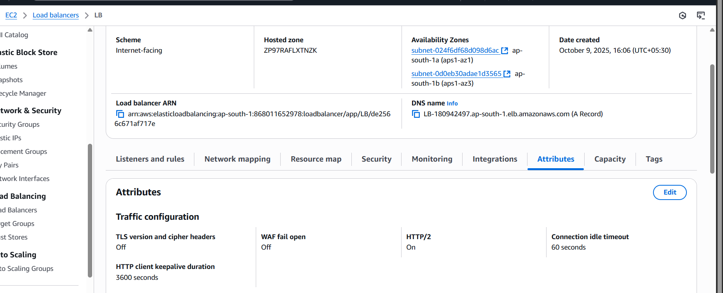

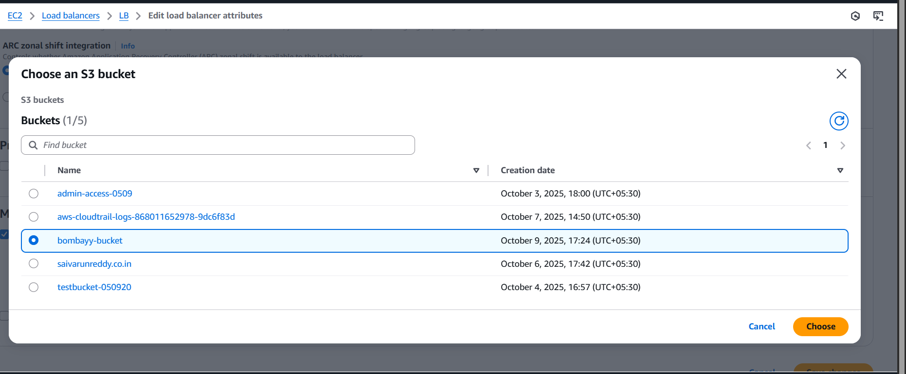

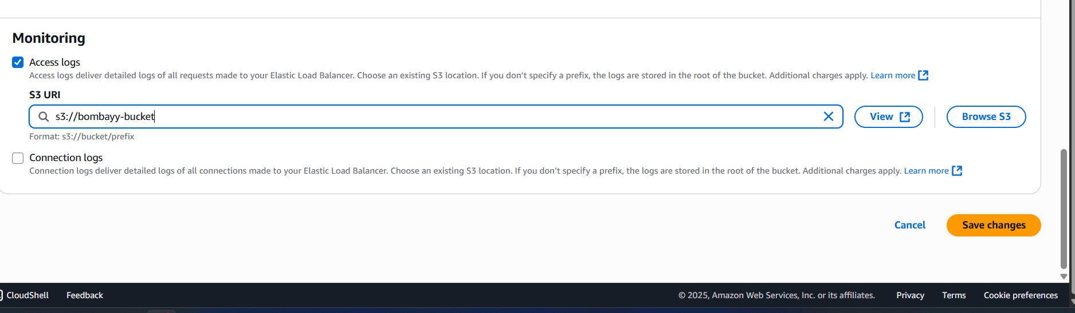

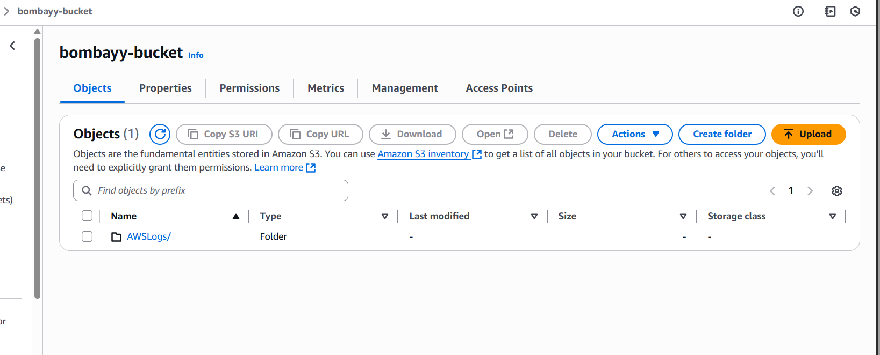

1. Store the VPC flow logs in a CloudWatch log group.

